Test plan for
Group 8 Omnibus Visualization
System

Authors: Brett Malmquist and Joe Cullinan

Group Members: Ben Miloshoff, Arjun Agrawal, Joe Cullinan, Geonhyuk Im, Brett Malmquist, Ekenechukwu Nwannunu, Adam Richard, Christian Schubert

ChangeLog

Version | Change Date | By | Description
version number | Date of Change | Name of person who made changes | Description of the changes made
0.1 | 2/27/2021 | Joe Cullinan & Arjun Agrawal | Main Page updated and links to each of other pages
0.2 | 3/8/21 | Ben Miloshoff | Implement Webex Into Mainpage
0.3 | 3/14/21 | Ben Miloshoff & Adam Richard | Main Menu Page Updated
0.4 | 3/22/21 | Brett Malmquist & Adam Richard | Histogram worked on
0.5 | 3/25/21 | Ben Miloshoff | BarChart worked on
0.6 | 3/28/21 | Geonhyuk Im, Ekenechukwu Nwannunu, and Christian Schubert | BoxPlot worked on
0.7 | 3/30/21 | Geonhyuk Im, Ekenechukwu Nwannunu, and Christian Schubert | GroupBoxPlot worked on
0.8 | 3/31/21 | Arjun Agrawal & Joe Cullinan | ScatterPlot worked on
0.9 | 4/4/21 | Arjun Agrawal & Joe Cullinan | StackedBarChart worked on
1.0 | 4/13/21 | Arjun Agrawal, Joe Cullinan, Ben Miloshoff, Brett Malmquist, & Adam Richard | Fixed issue with StackedBarChart not working
1.1 | 4/17/21 | Brett Malmquist and Joe Cullinan | Testing and debugging done

1 Introduction 2
1.1 Scope 2
1.1.1 In Scope 2
1.1.2 Out of Scope 2
1.2 Quality Objective 2
1.3 Roles and Responsibilities 2
2 Test Methodology 3
2.1 Overview 3
2.2 Test Levels 3
2.3 Bug Triage 3
2.4 Suspension Criteria and Resumption Requirements 3
2.5 Test Completeness 4
3 Test Deliverables 4
4 Resource & Environment Needs 4
4.1 Testing Tools 4
4.2 Test Environment 4
5 Terms/Acronyms 5

Introduction
The test stratagies that are going to be used is black box testing because this is mainly an input and output program. The process is going to be going through one page at a time starting with the home page making sure that the user can get to each page as directed and then testing each page that makes a graph. The methodology is iterative so once a iteration is done or a graph page then it will be tested and bugs will be found and then have to be fixed and then the errors will be tested to let the user know that there json code is incorrect and also point them to where it is incorrect. With it being iterative it will make it so that things are done in steps so each page and graph is a step.

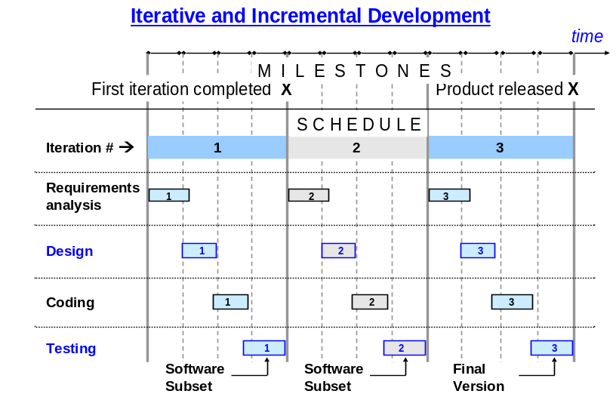

Scope

In Scope
The things that will be tested in the program will be each link to make sure you go to the correct page. When inputing the json errors will be tested to to see that they will be sent back to user if there is an error within there json. If the json is correct the output would have the graph in which they choose the make with there json.

Out of Scope
Things that will not be tested is taking other json code for other graphs and trying to use them for different graphs. Also, the way that the graphs are made will not be tested.

Quality Objective

- Making sure that the program works and is functional.
- All bugs and issues are found and identified and then fixed before launch.
- Ensure that the program meets the requirements set by the client

Roles and Responsibilities

Detail description of the Roles and responsibilities of different team members like
- PM- Project Manager: Coordinate all aspects of the project and its execution. Responsible for the health of the individual team members and the goals and objectives of the team’s project goals. Set up a timetable for the team to complete task. Responsible for the estimate of the scope and effort of each module.

- RE- Requirement Engineer: Communicate the User/Product Director’s desires to the team and translate from the U/PD’s user-oriented, and often abstract and changeable description of the user needs into high level function requirements for the product. Answers questions from the team regarding the product functionality and the desire of the functionality of the product.

- SA- Software Architect: Translates the RE’ high level functional requirements into high level design specifications. And UML modeling. Divide the product into two separate software modules. The technical lead for translating detailed functional requirements into detailed design specifications. Helps make prototype with some help form Re and IE. Makes data structures, database tables, GUI, and module design.

- IE- Integration Engineer: Responsible for the module interfaces and module integration. Also takes care of the data transferring between modules and the data integration. Produce integration source code. Responsible for common menu and help system technology the the standards for the product. Carry out prototype and demonstrate the prototype and the functionality of the product and how it looks and what it does.

- TE- Testing Engineer: Takes care of the functionality testing of the product and assurance of the quality of the product with testing. Design test case in conjunction with RE and CD. The lead for unit testing, system testing, and acceptance testing. Takes care of trouble-shooting modules and product in cooperation with all other members.

- CD- Code Developer (Every member): Produce functional and detailed requirements conjunction with RE. Produce detailed specification conjunction with SA. Develop code for modules. Responsible for the quality and functionality of delivered modules, including all aspects of integration with the rest of the product with the IE.

Test Methodology

Overview

Most of the Testing is going to be done with Black box testing which is what this program main functionality is taking input and then giving the user the output. We used iterative which means that the testing will only begin once one iteration is complete. So once one of the pages or graphs is complete the testing of that page will begin. Test cases will be used to test if the graph works as appropiate and then test cases to test for error or exceptions will also be done so the user will be able to tell where they may have messed up in there json. Bugs will be fixed after each iteration or in this case each page or graph for the website will be tested once completed.

Test Levels

The testing level for the project are as follows: Main Page setup and then making sure each link works.
Then work on one graph creating page at a time and then testing each one as it goes. Going back and redoing the testing process formt the beginning starting at the main page then going to each graph page again. The constraints that we had to deal with is the timing of everything. Making sure everything is getting done in a timely manner and that each graph is getting the attention and time it deserver so that the details will be done as specified by the client.

Bug Triage

- Problem integrating WebEx on main page: Fix alignment of code and brackets
- Histogram orientation needed to be fixed: had find way to rotate graph
- Histogram would only take 5 variables: had to make loop to take as many as needed.
- Scatterplot would not work properly: needed to place commas where needed in json
- Best fit line for scatterplot was not working properly: Had to create function to make it work.

Suspension Criteria and Resumption Requirements

- Suspension and Resumption will be done for testing while a page is being worked on and once a page is completed the testing will start to fix any bugs or issues that that page might have. If the graph does not work properly then the testing will be done to fix page.
- Another time it may resumed on a page when it is worked on if there is a major issue with the page to where it will not even work with eh basic functions like the links to the main menu or other such pages so that the basics may be fix so that it may be resumed to be worked on.
- Parts of testing will be resumed when the main function which is the graph is being worked on so that the graphs may be correct and then also made sure that they meet the client requirements and criteria.

Test Completeness

- 100% test coverage
- All Manual Test cases completed
- All open bugs are fixed or will be fixed in fianl version
- Every chart will work without bugs
- Everychart will give out correct error if input is wrong
- Each output will give correct chart and output

Test Deliverables

Here are the sample deliverables
- Test Plan
- Test Cases
- Bug Reports
- Test Strategy
- Output testing
- Input testing

Resource & Environment Needs

Testing Tools

- Bug Tracking Tool
- Debugging process
- Test code files

Test Environment
Following software’s are required in addition to client-specific software.

- Windows 8 and above

Terms/Acronyms
Make a mention of any terms or acronyms used in the project

TERM/ACRONYM | DEFINITION
PM | Project Manager
RE | Requirement Engineer
SA | Software Architect
IE | Integration Engineer
TE | Testing Engineer
CD | Code Developer
U/PD | User/Product Director

